SEMESTER 1, 2021/2022

CSCI 3301 CAAL Section 03

COMPUTER ARCHITECTURE AND ASSEMBLY LANGUAGE

 LECTURER: Dr. HAFIZAH BINTI MANSOR

**Assignment 1**

**PREPARED BY:**

|  |  |
| --- | --- |
| **NAME** | **MATRIC NO.** |
| MOHAMED MOUBARAK MOHAMED MISBAHOU MKOUBOI | 1820705 |

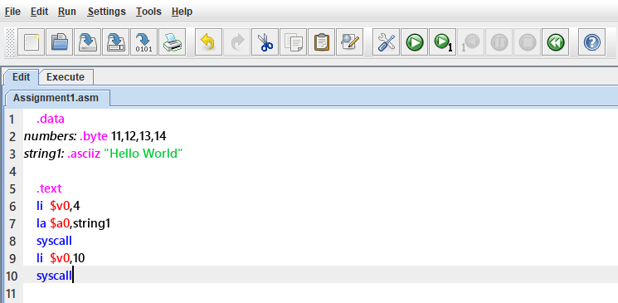

Open the (installed) MARS simulator. Open the source code “Assignment1.asm”. Save the file, then click “Run->Assemble”. Try to explore the different views including the text segment, data segment, I/O window, and registers. Then answer the followings:

1. What is the purpose of line 1?

The purpose of line 1 is where you started to store your data and declare them

1. What is the purpose of line 5?

Line 5 is here that we begin coding and conduct the operation with the data..

1. What is ***numbers***?

It is a variable that stores integer numbers

1. What is the difference between line 2 and line 3 in terms of the data stored in the data segment?

The difference is the data type and how the data is stored as we can see in line 2 the data are stored as integer and in line 3 they are stored as string

1. Where is ***numbers*** stored? What is the address of ***numbers***?

***numbers*** is saved in the register ***$v0***, with the address ***0x00400000.***

1. Where is ***string1*** stored? What is the address of ***string1***?

***string1*** is saved in the register ***$a0***, with the address ***0x00400000.***

1. What happens after line 6 is executed?

After the execution of line 6, the number 4will be stored at register ***$v0*** then the ***pc*** will store the address of the next line which is line 7(***0x00400004***) to proceed the execution of that next line.

1. What happens after line 7 is executed?

After the execution of line 7, the variable ***string1*** will be stored at register ***$a0*** then the ***pc*** will store the address of the next line which is line 8(***0x00400008***) to proceed the execution of that next line.

1. What happens after line 9 is executed?

After the execution of line 9, the number 10will be stored at register ***$v0*** then the ***pc*** will store the address of the next line which is line 8 (***0x00400014***) to proceed the execution.

1. Based on the syscall services table, what is the purpose of lines 6-8?

The purpose of line 6 is that service 4 is print integer and for the line 8 is to print the instruction before it:

